GSQ GML DD&T

Roadmap Executive Platform
  - Minimum Viable Product and Business Value

Marketplace purpose
Supporting document for the TakOS Marketplace order. It defines the MVP hypothesis, business experience, scope, delivery responsibilities, success measures, value, risks, and the functional design package required for TakOS implementation.

Executive Sponsor: Joel Vincent
Business Sponsor / Product Lead: Dean Santoro
Global Manufacturing & Labs DD&T
September 2026

1. Executive Summary
The GSQ DD&T Roadmap Executive Platform is a proposed TakOS-enabled leadership product that will consolidate portfolio, investment, delivery, site performance, business-capability deployment, North Star adoption, and value-realization information into a single executive experience. The MVP will use Jira, SPOT, and EDB as primary data sources from the outset so that all three components of the Executive Platform are designed, integrated, built, and evaluated together.
Decision requested
Approve an approximately $168,000, six-to-twelve week MVP to validate the complete Executive Platform concept using Jira, SPOT, and EDB data, current GML product-definition resources, and AI&D engineering and testing support.

The MVP will prove six things
- Jira contains sufficient portfolio and delivery data for executive roadmap reporting.
- SPOT contains sufficient investment and project information for executive reporting.
- EDB contains sufficient deployment, adoption, utilization, and business-capability data for executive reporting and value-realization insight.
- A TakOS-based executive experience can be delivered using standard, reusable patterns.
- Executives can obtain portfolio status and business-review insights without relying on multiple manually assembled presentations.
- The concept creates enough measurable value to justify a prioritized multi-release product roadmap.

A validated, integrated executive-platform MVP spanning Roadmap, Business Review, and Business Capability / North Star experiences; a reusable TakOS product pattern; tested Jira, SPOT, and EDB integration approaches; and an evidence-based roadmap for subsequent enhancements and broader GSQ use.
A validated executive-platform concept, a reusable TakOS product pattern, a tested integration approach, and an evidence-based roadmap for Releases 1 through 3 and broader GSQ use.

2. Business Problem and Opportunity
Leadership information is currently distributed across separate Jira views, SPOT reports, site-specific tools, PowerPoint business reviews, and manually consolidated status reports. This creates delayed visibility, difficult portfolio comparisons, manual reconciliation of delivery and investment information, and substantial effort spent preparing leadership communications instead of managing execution.

Opportunity
Create a governed, reusable leadership product that transforms data already maintained in approved enterprise systems into a common executive experience for portfolio health, roadmap execution, funding alignment, site performance, capability deployment, adoption, and value realization.
Current state | MVP / target direction | Business effect
Multiple reports and presentations | Single executive navigation and reporting experience | Faster access to portfolio information
Separate Jira and SPOT views | Aligned delivery and investment views | Better prioritization and escalation
Site-specific reporting approaches | Reusable Global-by-Design pattern with local views | Greater consistency with appropriate local detail
Manual business-review preparation | Standardized, data-driven review experience | More time focused on execution
Limited deployment/adoption visibility | Integrated EDB-enabled capability, North Star deployment, adoption, utilization, and value-realization experience within the MVP | Stronger value-realization oversight

3. MVP Scope and Release Strategy
Product | MVP scope | Primary data | MVP success criterion
1. GSQ DD&T Roadmap Executive Platform | Portfolio health, initiative tracking, roadmap visualization, status, milestones, and executive dashboards | Jira, SPOT, and relevant EDB data | Executives can understand portfolio status without reviewing multiple PowerPoints.
2. Business Review Platform | Thousand Oaks pilot; site initiative status, project delivery metrics, KPI and executive-review views | Jira, SPOT, and relevant EDB data | Replace manually assembled business-review reporting for the pilot experience.
3. Business Capability / North Star Deployment & Adoption | Working MVP capabilities for business-capability status, North Star deployment, adoption, utilization, maturity indicators, and value-realization analytics | EDB, integrated with relevant Jira and SPOT context | Demonstrate that EDB data can support executive views of capability deployment, adoption, utilization, and value realization within the integrated platform.

MVP boundary
The MVP includes all three products as one integrated Executive Platform. The build must provide Jira, SPOT, and EDB access from the outset and deliver working Roadmap, Business Review, and Business Capability / North Star deployment, adoption, utilization, and value-realization experiences. EDB capabilities are not deferred to a later release; EDB data-product validation and integration are part of MVP execution and acceptance.

Proposed release sequence
Release | Focus
Release 1 | Integrated Executive Platform MVP: Roadmap, Business Review, and Business Capability / North Star experiences using Jira, SPOT, and EDB
Release 2 | Scale the integrated platform across additional sites, executive workflows, and reusable reporting patterns
Release 3 | Enhance analytics, automation, value realization, and AI-assisted executive insights based on MVP evidence

4. Business Design Package
The GML team is responsible for defining the business experience and producing a complete functional blueprint. The TakOS delivery team should not need to invent business processes, user journeys, screen behavior, KPI definitions, or executive reporting requirements.
Design-package component | Required content
Business workflows and user journeys | End-to-end workflows for executive, leadership, site, product, and operational users, including decisions, outcomes, navigation, and interactions across platform components.
Screen inventory and navigation model | Required pages, dashboards, drill-downs, filters, entry points, role-based views, and navigation paths.
High-fidelity Claude Design mockups | Look and feel, layouts, navigation flow, user experience, executive dashboards, and analytics concepts.
Business Review experience | Review dashboards, KPIs, site performance, portfolio health, project health, and executive review workflow using Thousand Oaks as the test case.
Business Capability / North Star experience | Presentation of business capability status, deployment progress, adoption, maturity indicators, and value-realization concepts.
Data and functional requirements | For every screen: required data, source system, calculations, business rules, filters, drill-downs, KPI definitions, reporting behavior, security assumptions, and refresh expectations.
MVP prioritization | Minimum viable scope, Release 1 features, future-release candidates, dependencies, assumptions, and acceptance criteria.

Final output
A single Business Design Package containing workflow diagrams, user journeys, screen inventory, navigation architecture, approved mockups, data requirements, KPI and business-rule definitions, MVP scope, dependencies, and acceptance criteria. This package will serve as the functional specification for the TakOS development team.

5. Delivery Model and Process
Phase | Key activities | Primary output
1. Scope and hypothesis | Confirm Products 1-3, MVP boundary, data sources, personas, decisions, and success measures. | Approved MVP definition
2. Experience design | Create workflows, user journeys, screen inventory, navigation, mockups, and data requirements. | Business Design Package
3. Funding and onboarding | Submit Marketplace package, confirm funding, delivery resources, governance, repositories, and access. | Approved delivery engagement
4. MVP build | Implement the TakOS front end, APIs, security integration, Jira/SPOT/EDB data products, dashboards, workflows, and all three Executive Platform components. | Working MVP
5. Test and pilot | Functional testing, user testing, data validation, executive evaluation, and reuse assessment. | MVP Assessment Report
6. Full-product decision | Confirm architecture, ownership, support model, funding, and prioritized Releases 1-3. | Evidence-based product roadmap

Responsibilities
GML business / design team | TakOS delivery team
Business processes, personas, user journeys, workflow definitions, screen designs, mockups, data requirements, KPI definitions, prioritization, and business acceptance. | Front-end and back-end development, data engineering, APIs and integrations, security implementation, automated and functional testing support, deployment, and technical delivery controls.

Explicitly out of scope for the business-design team
Front-end development, back-end development, data engineering, system integration, automated testing, and deployment. These activities are owned by the TakOS delivery team in accordance with the approved MVP approach.

6. Business Value and Success Measures
Productivity value
The value case projects approximately 9,000 hours of annual productivity savings across 18 GSQ Manufacturing & Labs sites. This equates to approximately 500 hours per site per year, or nearly 42 hours per site per month, by reducing portfolio-management, reporting, and executive-communication effort.

Value driver | Current state | Expected benefit
Reduced management reporting effort | Teams manually create presentations and status updates. | Less report preparation and more time focused on execution.
Improved portfolio governance | Portfolio information is distributed across systems. | Faster escalation, better prioritization, and improved leadership visibility.
Better investment decisions | Funding and delivery data require manual reconciliation. | Improved resource allocation and earlier identification of constraints.
Reusable product pattern | Sites may create separate reporting solutions. | Reduced duplication, faster reuse, and lower future development effort.
Deployment and adoption insight | Capability information is not yet integrated into the executive experience. | MVP visibility into whether North Star systems are deployed, adopted, utilized, and supporting intended business capabilities and value realization.

MVP success measures
Dimension | Measure
Technical | Jira, SPOT, and EDB data can be consumed reliably; integration quality, freshness, and availability are acceptable; all three Executive Platform components operate within the TakOS MVP.
Business | Executive sponsors find value; leadership visibility improves; manual reporting effort is reduced; pilot workflows support executive decisions.
Strategic | Reusable components are identified; a prioritized Releases 1-3 roadmap is defined; ownership and funding models are established; a full-product funding decision can be made.

7. Risks, Assumptions, and Controls
Risk / assumption | Likelihood | Impact | Planned control
Jira, SPOT, or EDB data are incomplete, inconsistent, unavailable, or not sufficiently structured. | Medium | High | Validate hierarchy, relationships, financial attributes, capability data, deployment and adoption signals, metadata, quality, freshness, access, and availability during the MVP.
API, security, or data-product access delays implementation. | Medium | High | Confirm dependencies during onboarding and assign technical owners before build execution.
Scope expands beyond the six-week MVP. | Medium | Medium | Maintain a prioritized backlog while preserving the non-negotiable MVP boundary: all three platform components and Jira, SPOT, and EDB integration.
Executive users do not adopt the experience. | Medium | High | Design around explicit executive decisions and pilot with sponsors before full-product investment.
Ownership and operational support remain unclear. | Medium | High | Use MVP output to define product, technical, operations, and funding ownership.
If the solution is not realized, fragmented reporting and manual analysis continue. | High | High | Use MVP evidence to quantify value, validate feasibility, and enable an informed investment decision.

8. Current Prototype Evidence
The existing prototype demonstrates that roadmap information can be presented through global, initiative, region, site, risk, and milestone views. The attached capability tracker also illustrates the intended direction for future deployment and adoption reporting. These artifacts are evidence of the business concept and are inputs to the refined TakOS design package, not the final production solution.
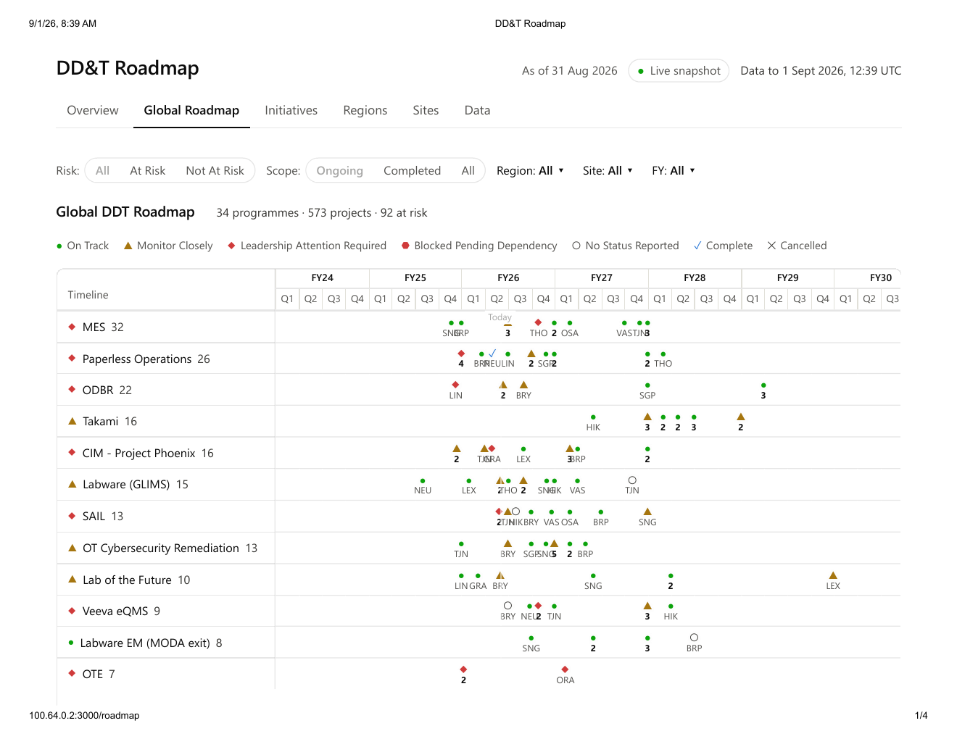
Figure 1. Current global roadmap prototype

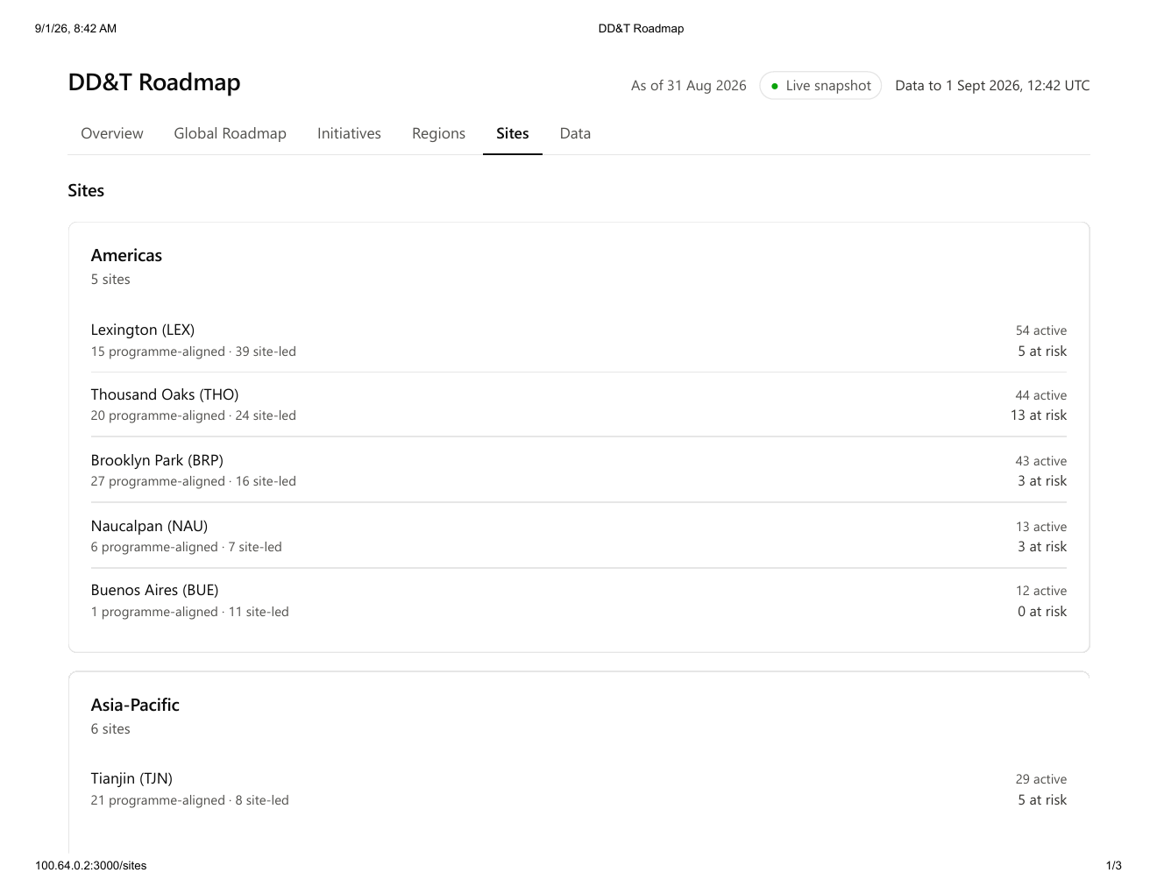
Figure 2. Current site-level roadmap prototype

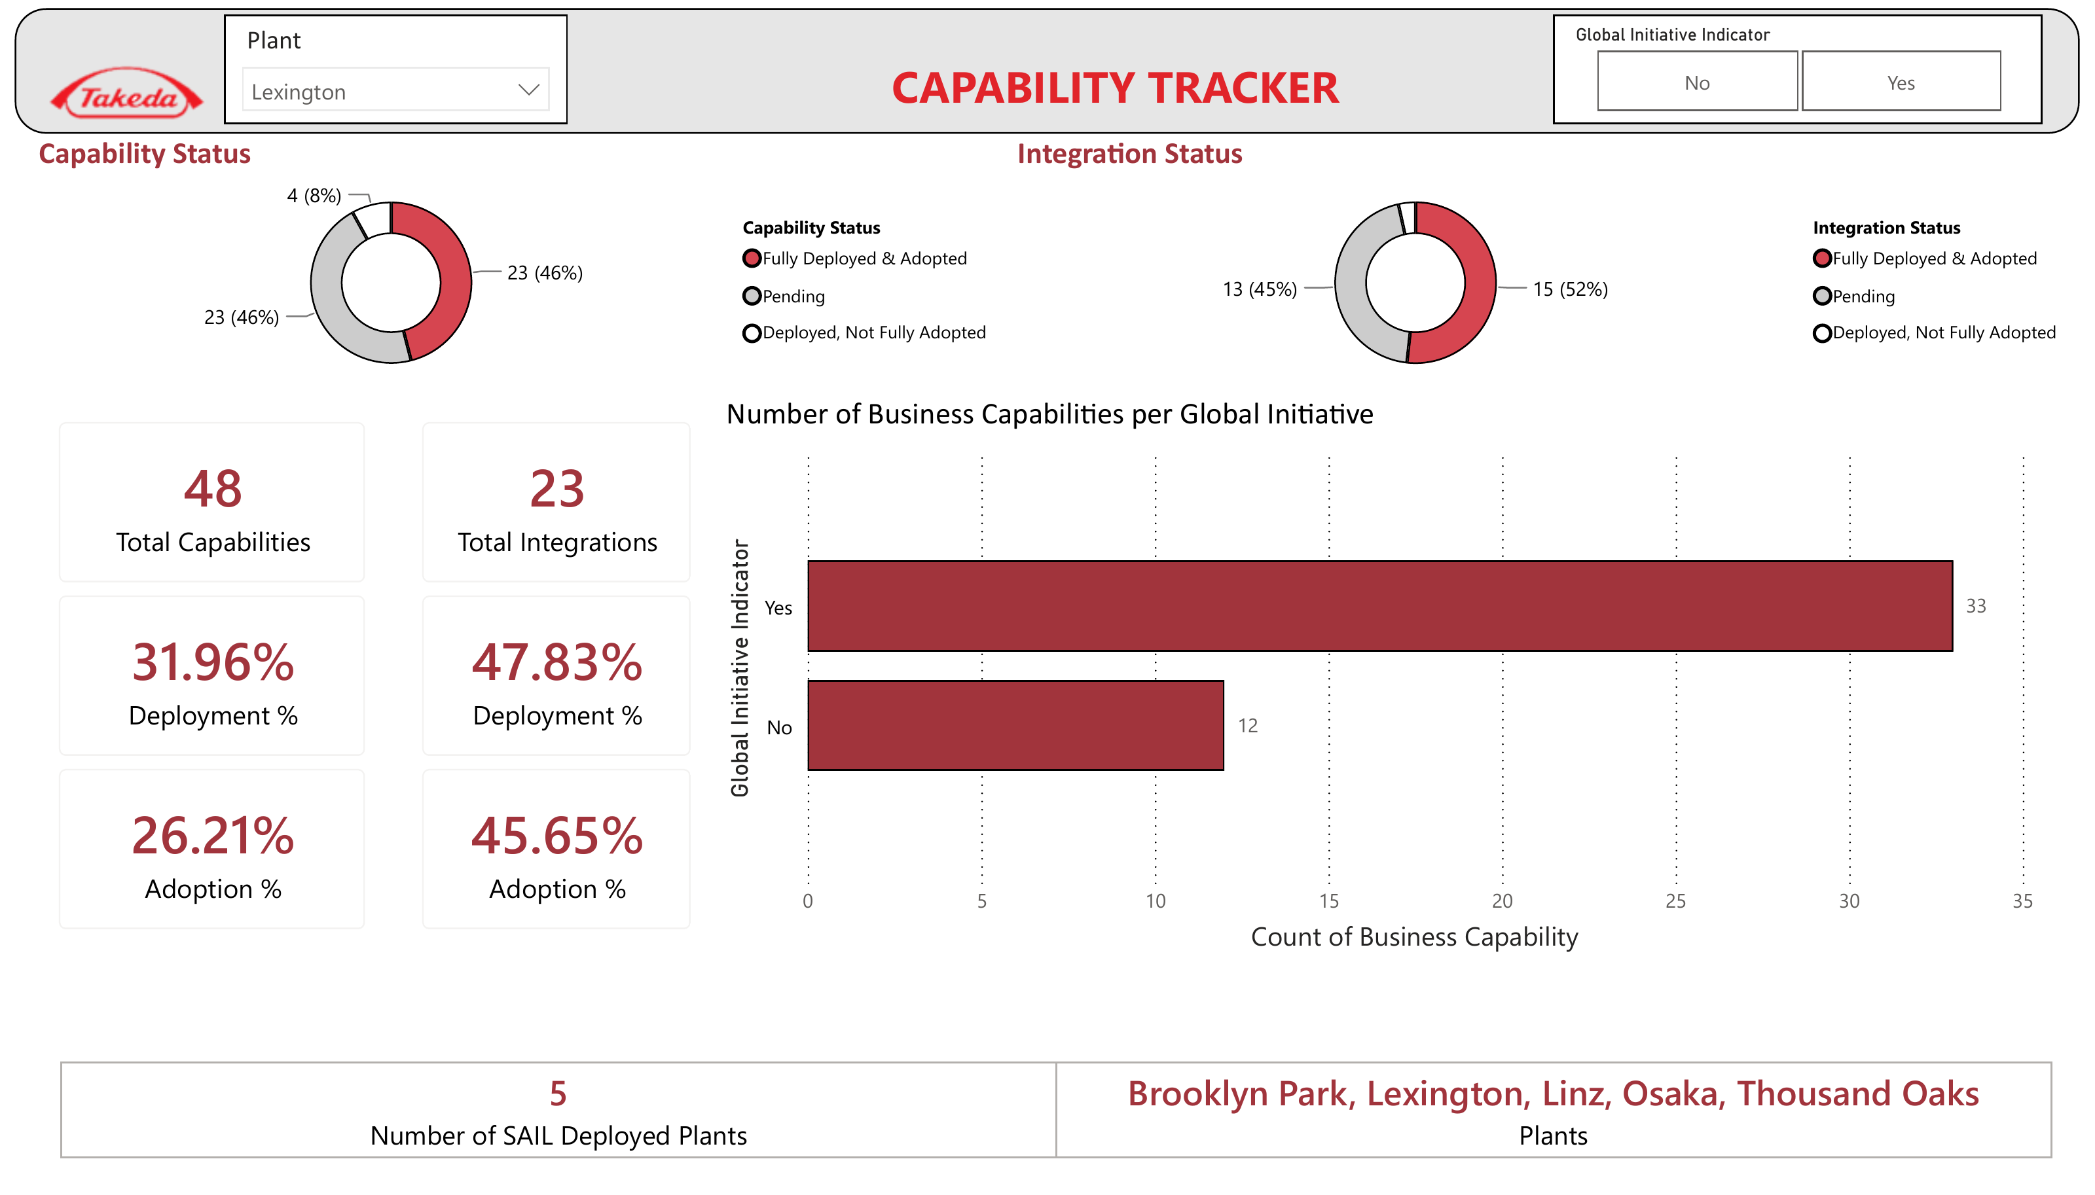
Figure 3. Current capability deployment and adoption concept

9. Marketplace Decision Summary
Item | Proposed position
Request | Approve the TakOS engagement and funding required to deliver and evaluate the MVP.
Duration | Six-week MVP.
Investment | Approximately $40,000 proposed MVP investment.
Initial build scope | Complete integrated Executive Platform MVP covering the GSQ Roadmap, Thousand Oaks Business Review, and Business Capability / North Star deployment and adoption experiences using Jira, SPOT, and EDB.
Design scope | Complete functional blueprint and working MVP across the Roadmap, Business Review, and Business Capability / North Star experiences.
Deferred capability | None of the three core Executive Platform components are deferred. Only post-MVP enhancements and broader rollout are sequenced after MVP evaluation.
Outcome | Validated concept, working MVP, assessment report, reusable TakOS pattern, and prioritized roadmap for Releases 1-3.

Recommendation
Proceed with the MVP as an integrated validation investment. Jira, SPOT, and EDB access, data-product validation, and all three Executive Platform components are required within the MVP so leadership can evaluate the complete executive experience and its end-to-end value.

